**VEHICLE-TO-GRID TECHNOLOGY IN A MICRO-GRID USING DC FAST CHARGING ARCHITECTURE**

Abstract— Electric Vehicle (EV) batteries can be utilized as potential energy storage devices in micro-grids. They can help in micro-grid energy management by storing energy when there is surplus (Grid-To-Vehicle, G2V) and supplying energy back to the grid (Vehicle-To-Grid, V2G) when there is demand for it. Proper infrastructure and control systems have to be developed in order to realize this concept. Architecture for implementing a V2G-G2V system in a micro-grid using level-3 fast charging of EVs is presented in this paper. A micro-grid test system is modeled which has a dc fast charging station for interfacing the EVs. Simulation studies are carried out to demonstrate V2G-G2V power transfer. Test results show active power regulation in the micro-grid by EV batteries through G2V-V2G modes of operation. The charging station design ensures minimal harmonic distortion of grid injected current and the controller gives good dynamic performance in terms of dc bus voltage stability.

**INTRODUCTION ABOUT ELECTRIC VEHICLE**

Electric vehicle is an automobile propelled by one or more electric motors, drawing power from an onboard source of electricity. Electric cars are mechanically simpler and more durable than gasoline-powered cars. They produce less pollution than do gasoline-powered cars. An electric car stores its energy on board-typically in batteries, but alternatively with capacitors or flywheel storage devices. A more recent development is the hybrid electric vehicle (HEV), which uses both an electric motor or motors and a gasoline or diesel engine, which charges the batteries in order to extend the car's range and often to provide additional power. Regardless of the energy source, an electric car needs a controller, which is connected to the accelerator pedal, for directing the flow of electricity from the energy source to the motor. Most electric cars use lead-acid batteries, but new types of batteries, including zinc-chlorine, nickel metal hydride and sodium-sulfur, are becoming more common. The motor of an electric car harnesses the battery's electrical energy by converting it to kinetic energy. The driver simply switches on the power. selects "Forward" or "Reverse" with another switch. and steps on the accelerator pedaL While the internal-combustion engine of a conventional car has many movmg parts and must convert the linear motion of pistons and rods into rotary motion at the wheels, an electric motor has only a single rotating element. Like a gasoline-powered car, an electric car has a system (called a power train) of gears, shafts. and joints that transmit motion from the motor to the car wheels. Most electric cars do not have clutches or multi speed transmissions. In order to go backward, the flow of electricity through the motor is reversed, changing the rotation of the motor and causing the power train to make the wheels rotate in the other direction. Most electric cars have a regenerative braking system-the braking system acts as a battery charger. When a driver ease up on the accelerator or step on a brake pedal, the drive motor acts as a generator and converts the vehicle's momentum back into electricity and stores it in the battery. Converting the kinetic energy into electric energy slows the car. Electric cars also have a brake pedal and a traditional braking system, which uses friction to slow the vehicle for quick and emergency stopping. These friction brakes convert kinetic energy to heat. In gasoline-powered cars this energy 1s wasted, the heat being dissipated into the surrounding air. Energy conservation in electric cars, however, is so important that engineers found a way to recover the heat and use it-for example, by heating the passenger compartment Electric Car, automobile propelled by one or more electric motors, drawing power from an onboard source of electricity. Electric cars are mechanically simpler and more durable than gasoline-powered cars. They produce less pollut1on than do gasolier-powered cars.

**Working Principle Of Electric Vehicle.**

An electric car stores its energy on board-typically in batteries, but alternatively with capacitors or flywheel storage devices. Or it may generate energy using a fuel cell or generator. A fuel cell is a specialized form of battery that combines hydrogen with oxygen in a chemical reaction that produces electricity and water vapor.

Unlike an electric cell or battery, a fuel cell does not run down or require recharging; it operates as long as the fuel and an oxidizer are supplied continuously from outside the cell. Most current versions of electric cars use some combination of these energy sources. "Pure" electric cars, however, run only on batteries and need a charger to replenish the battery's power from an electrical outlet. A more recent development is the hybrid electric vehicle (HEV), which uses both an electric motor or motors and a gasoline or diesel engine that charges the batteries in order to extend the car's range and often to provide additional power. Regardless of the energy source, an electric car needs a controller, which is connected to the accelerator pedal, for directing the flow of electricity from the energy source to the motor.

Most electric cars use lead-acid batteries, but new types of batteries, including zinc-chlorine. Nickel metal hydrides, and sodium-sulfur, are becom1ng more common The motor of an electric car harnesses the battery's electrical energy by converting it to kinetic energy. The driver s1mply switches on the power. Selects "Forward" or "Reverse" with another sw1tch and steps on the accelerator pedal.

While the internal-combustron engrne of a conventional car has many moving parts and must convert the linear motion of pistons and rods into rotary motion at the wheels, an electric motor has only a single rotating element. Like a gasoline-powered car, an electric car has a system (called a power train) of gears, shafts, and joints that transmit motion from the motor to the car wheels.

Most electric cars do not have clutches or multispeed transmissions. In order to go backward, the flow of electricity through the motor is reversed, changing the rotation of the motor and causing the power train to make the wheels rotate in the other direction. Most electric cars have a regenerative braking system-the braking system acts as a battery charger. When drivers ease up on the accelerator or step on a brake pedal, the drive motor acts as a generator and convert the vehicle’s momentum back into electricity and store it in the battery. Converting the kinetic energy into electric energy slows the car. Electric cars also have a brake pedal and a traditional braking system, which uses friction to slow the vehicle for quick and emergency stopping. These friction brakes convert kinetic energy to heat. In gasoline-powered cars this energy is wasted. the heat being dissipated into the surrounding air. Energy conservation in electric cars. however, is so important that engineers found a way to recover the heat and use it-for example, by heating the passenger compartment.

**Need Of Electric Vehicle**

Electric Vehicle (EV) technology is gaining ground and popularity rapidly. With depletion of oil reserves and a world characterized by smog, noise and all kinds of pollutants, governments and communities are awakening to the several b~nefits of EV technology. Zero emission vehicles are almost noiseless and can be charged at home or work, saving commuters endless queues at petrol stations. Charging at night when consumption is low, allows for efficient use of electricity. EVs are easier to service and maintain due to the absence of spark plugs, clutch and gears. Ideal for "stop - start" city driving conditions, EVs are extremely reliable and easy to drive. With the innumerable advantages of EVs, companies in developed countries have spent huge amounts to develop electric cars that can travel longer distances, providing high levels of comfort. In spite of this technology being available now, the cost of electric vehicles to suit driving requirements in these developed countries is prohibitively high.

**History Of Electric Vehicles**

Few people realize that successful electric automobiles were being produced as early as the 1880's. For over 20 years, electric cars were commercially produced. And were for some years in heady competition with Internal combustion and steam-powered carriages. Not until internal combust1on technology and promotion, along with cheap fuel, had 144 outstripped all competition, did electric cars drop out of the automotive picture. The technology required for the electric car was being developed long before the automobile was conceived. The primary cell invented by Volta in 1800, generated electricity by chemical action.

Only replacing the active elements could recharge this primitive battery. Not until 1860, when Gaston Faure invented the secondary cell, could simply passing a current through it recharge a battery providing portable, renewable electric power. In spite of earlier experimental work, a working electric motor was not built until 1833. Thomas Davenport, an uneducated Vermont blacksmith, conceived it after observing a demonstration of an electromagnet. Davenport patented his motor in 1837. Davenport had in fact built a model electric locomotive as early as 1834, powered by primary cells. In 1847, Moses Farmer, from Massachusetts designed a locomotive that, powered by 48 one-pint cells, could carry two people along an 18-inch-wide track. About the same time, Professor Charles Page of Washington, D.C., built a locomotive which, using 100 cells and a 16-horsepower motor, carried twelve people on the Washington and Bladensburg Railroad at up to 19 mph in 1847.

Lilly and Colton of Pittsburgh built a locomotive, which rece1ved 1ts power. Produced from a central station, through an electrified rail In 1888, electric cars suddenly began appearing on the scene both in the U.S. and in other countries. The first really successful electric automobile was the carriage built by William Morrison of Des Moines, Iowa, in 1890. Morrison's car used high, spoked wagon wheels to negotiate the rutted roads of America, and an innovative guidance system, which included patented rack-and-pinion steering. Morrison's car was capable of running for 13 consecutive hours at 14 mph. Much of the car's success, however, was attributable to the promotional efforts of Harold Sturges, secretary of the American Battery Company.

**Advantages And Disadvantages**

Electric cars represent a cleaner way to convert fossil fuels-oil (Petroleum), coal, and natural gas (Gases, Fuel) produced from the remains of prehistoric plants and animals-to automotive power. The fossil fuels are burned at a power plant, or onboard in hybrid electric vehicles, to make electricity to recharge the battery. Substances that pollute the air can be controlled more easily at a power plant than at the tailpipes of millions of gasoline-burning cars, and in hybrid electric vehicles, electronic controls can be used to make the engines run only as needed and to do so more efficiently. The result is that air quality, especially in large cities, can be 1mproved with electric cars or hybrid electric vehicles. Today's electric cars are more efficient than gasoline-powered cars. They are cons1dered an easy and effective way to harness existing energy sources because any energy source can be converted into electncity. Pure electric cars do not require new ways of delivering fuel because electricity is already distributed to virtually every home and business. However, pure electric cars require charging stations, special equipment that can recharge an electric car battery quickly and efficiently. This special equipment can be installed in a home garage or in the trunk of the car. To extend the range of an electric car, charging stations would need to be placed strategically throughout a city. Despite the advantages of more efficient energy use, pure electric cars have not been widely adopted. Pure electric cars are impractical because current battery technology limits the distance an electric car can travel before its battery must be recharged. This distance is currently less than 160 km (1 00 mi) in most cases, and the batteries take at least three hours to recharge using charging stations. Electric cars are not yet able to accelerate, cruise, and climb fast enough to compete with gasolinepowered cars. And accessories, such as air conditioning or radios, drain the battery even more quickly. Moreover, because electric cars have not been widely adopted, few public charging stations are in existence. Electric cars represent a cleaner way to convert fossil fuels-oil,coal, and natural gas produced from the remains of prehistoric plants and animals to automotive power The fossil fuels are burned at a power plant, or onboard 1n HEVs. to make electricity to recharge the battery.

Substances that pollute the air can be controlled more easily at a power plant than at the ta1lp1pes of millions of gasoline-burning cars, and in HEVs. Electronic 1~7 controls can be used to make the engines run only as needed and to do so more efficiently. The result IS that a1r quality, especially in large Cities, can be improved with electric cars or hybrid electric vehicle. Today's electric cars are more efficient than gasoline-powered cars. They are considered an easy and effective way to harness existing energy sources because any energy source can be converted into electricity. Pure electric cars do not require new ways of delivering fuel because electricity is already distributed to virtually every home and business. However, pure electric cars require charging stations, special equipment that can recharge an electric car battery quickly and efficiently. This special equipment can be installed in a home garage or in the trunk of the car. To extend the range of an electric car, charging stations would need to be placed strategically throughout a city.

Despite the advantages of more efficient energy use, pure electric cars have not been widely adopted. Pure electric cars are impractical because current battery technology limits the distance an electric car can travel before its battery must be recharged. This distance is currently less than 160 km (100 miles) in most cases, and the batteries take at least three hours to recharge using charging stations. Electric cars are not yet able to accelerate. cruise. And climb fast enough to compete with gasoline powered cars. And accessories, such as air conditioning or radios, drain the battery even more qu1ckly. Critics of electric vehicle point out that in add1t1on to the contrast 1n range. The large batteries needed to store energy in the vehicles are a serious environmental hazard. Environmentalists often refute these claims because the batteries can be recycled with minimal environmental impact and more advanced batteries such as lithium ion and nickel metal hydride batteries might give the cars the range of conventional gas cars. Due to lack of production volume, these batteries are currently 3-4 times more expensive than conventional Lead Acid or Nickel Cadmium batteries. Firefighters and rescue personnel require special training to deal with the higher voltages encountered in electric vehicle accidents. 5.6 Indian Electric Vehicles India is ready and well suited for the introduction of EVs today with the existing technologies available, making EVs cost effective.

The ideal EV for India and the developing world is basic, simple and reliable - designed specially for local conditions using cutting edge technology and which is modular to incorporate and absorb newer technologies. EVs with a top speed of 40-60 kmph and a range of 50-80 km would meet over 90 percent of the city mobility requirements in India. The first electric car in India was launched by Bangalore based company REVA was conceptualized and designed to meet these needs and performance specifications. REVA is designed to be unique and stands out on the road as a genu1ne city car with a mature expression. The advanced technologies used. make it highly differentiated and superior to other 149 makes. It has all the inherent benefits of an Electric Car and is indeed a revelation in city mobility.

le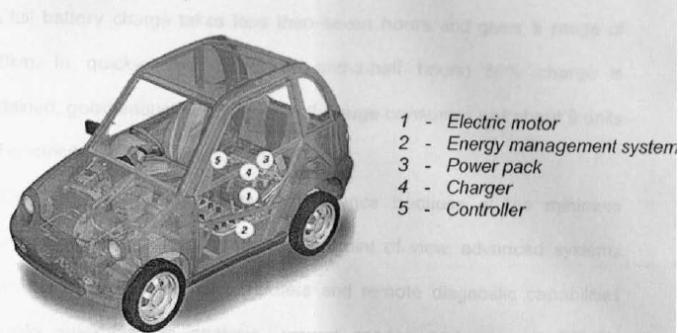

Fig REVA Electrical Vehicle

It is a fully automatic (no clutch - no gears), two-door hatchback, easily seating two adults and two children. A small turning radius of just 3.5 meters makes it easy to park and maneuvers in difficult city traffic conditions. Driving REVA is easy. Just unplug after completing the charging process, turn the key, disengage the parking brake, and turn the control knob to the forward (or reverse) position. Accelerate and take off. It runs on batteries and as compared to other Electric Vehicles has an onboard charger to facilitate easy charging, which at home plugging into any 15 Amp socket at home or work can carry out. As simple as charging a mobile phone! The onboard charger ensures the safety of the car in case of any voltage fluctuation or any electnc spikes The auto cut off mechanism ensures that 150 the customer does not have to worry about overcharging or any other issues related to charging. A full battery charge takes less than seven hours and gives a range of 80km. In quick-charge mode (two-and-a-half hours) 80% charge is attained, good_ enough for 65km. A full charge consumes just about 9 units of electricity. REVA requires extremely low maintenance because of the minimum number of moving parts. From service point of view, advanced systems such as the two onboard computers and remote diagnostic capabilities enable quick vehicle analysis, prompt service and improve REVA's performance and efficiency.

**Major Parts In Reva Car I.**

**Motor**

The prime mover in REVA, is the motor. It is comparable to the engine in a conventional car. REVA has a 13 kW separately excited DC motor with a high torque of 70 Nm at zero speed. When in use, the motor converts the energy stored in the Power Pack into mechanical motion. The high torque electric motor ensures a quick acceleration. The power from the motor is delivered to the wheels through the Trans-axle that propels the vehicle. While braking, the motor acts like a generator (regenerative braking) and recharges the Power Pack.

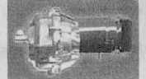

**II. Power Pack**

I ) I REVA's Power Pack consists of eight 6-Volt EV tubular type lead acid batteries that attain 80% state of charge (quick-charge mode) in under 2.5 hours. A complete charge is achieved in less than seven hours and gives a range of * 80km. The Power Pack is housed beneath the front seats, which lowers the center of gravity, thus increasing the safety of passengers. Charging REVA is a safe and easy process - just plug into a 220 Volt, 15 Ampere socket - at home or at work. A full charge consumes just about 9 units of electricity.

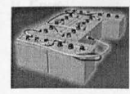

**III Charger**

REVA has an on-board Charger, which converts AC into DC power to charge the power pack. The charger is computer controlled with an in-built stabilizer and auto shut-off mechanism. The smart charger's output is connected to the Power Pack and ensures that optimum current and voltage is maintained at all times.

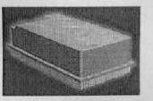

**IV. Controller**

REVA also has a computerized Motor Controller. This regulates the flow of energy from the Power Pack to the Motor in direct relation to pressure applied on the accelerator. It ensures perfect speed control and optimum use of energy in both forward and reverse directions.

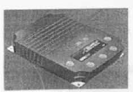

**V. Ems**

The brain of REVA is the Energy Management System (EMS) that monitors and controls all vital functions. The EMS is a computer-based system that optimizes charging and energy output of batteries to maximize operating range and improve performance. The system also predicts available range for a given state of battery charge and is a standard feature on the REVA. The EMS also maintains an electronic log of the vehicle performance, enables service personnel to run diagnostic checks on the car to give service information about the car

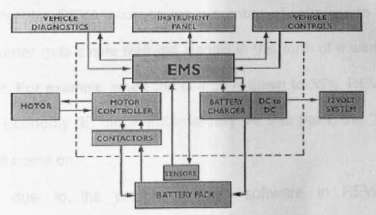

Fig Energy management system

**Why Evs Are Not Popular**

Evs available in market are having great features and can compete with the conventional gasoline vehicles. But still it is not as successful as gasoline-based vehicles specially in India. There are some myths attached w1th the EVs.

**Safety And Reliability Of Evs: I '\**3

The general perception among people was that EVs are not safe. To counter this RECC took extra precaut1on in the design to incorporate many safety features - like the steel space frame, side impact beams, dent-proof ABS body panels, low voltage system, and dual braking system. All these featl!res lead to a very high level of reliability and safety. Today all our customers are convinced of the fact that EVs are safer than any of the conventional vehicles available on the road.

Fear Of Running Out Of Charge In The Middle Of The Road: Many customers had this fear that without proper warning the car will run out of charge leaving them stranded. To counter this REVA incorporates a number of warnings to ensure that the customer gets ample warning signals in the form of a warning display on the IP. For example, when the charge is down to 35%, REVA will move into the Economy (E) mode automatically. At this point, the "Low Battery Light" will come on. This is due to the pre-programmed software in REVA's Energy Management System (EMS) and motor controller. These warning signals ensure. as far as possible that the customer is never stranded on the road due to insufficient energy in the power pack. When the charge in the power pack reduces to 25% state-of-charge the "Low Battery Light" starts flashing. At 15% state of charge, REVA automatically switches to Limp-Home Mode, limiting your acceleration and speed. enough to help you reach home or the nearest charging point. /54 5.7.3 The Most Prominent Reason Behind The Low Demand Of Evs The most important point, which IS to be considered, is the low efficiency of the car. Sine~ a fully charged car can run up to 70-80 km and after that it is required to charge again and for that one need a charging station. To charge the battery fully it takes about 6-7 hrs. So such cars are not suitable for the long journey. But there are some possible ways to improve the efficiency of the EVS. And by increasing the efficiency one can travel for longer distance after charging once.

**MATLAB**

**Introduction to Mat lab:**

Mat lab is a high-performance language for technical computing. The name mat lab stands for matrix laboratory. It integrates computation, visualization, and programming in an easy-to-use environment where problems and solutions are expressed in familiar mathematical notation. Typical uses include Math and computation Algorithm development Data acquisition Modeling, simulation, and prototyping Data analysis, exploration, and visualization Scientific and engineering graphics Application development, including graphical user interface building.

Matlab is an interactive system whose basic data element is an array that does not require dimensioning. This allows you to solve many technical computing problems, especially those with matrix and vector formulations, in a fraction of the time it would take to write a program in a scalar no interactive language such as C or FORTRAN.

**History of Matlab:**

Cleve Barry Moler, the chairman of the [computer-science](http://en.wikipedia.org/wiki/Computer_science) department at the [University of New Mexico](http://en.wikipedia.org/wiki/University_of_New_Mexico), he is a [mathematician](http://en.wikipedia.org/wiki/Mathematics) and [computer programmer](http://en.wikipedia.org/wiki/Computer_programming) specializing in [numerical analysis](http://en.wikipedia.org/wiki/Numerical_analysis). Started developing MATLAB in the late 1970s. He designed it to give his students access to [LINPACK](http://en.wikipedia.org/wiki/LINPACK) and [EISPACK](http://en.wikipedia.org/wiki/EISPACK) without their having to learn [Fortran](http://en.wikipedia.org/wiki/Fortran). It soon spread to other universities and found a strong audience within the [applied mathematics](http://en.wikipedia.org/wiki/Applied_mathematics) community. [Jack Little](http://en.wikipedia.org/wiki/John_N._Little), an engineer, was exposed to it during a visit Moler made to [Stanford University](http://en.wikipedia.org/wiki/Stanford_University) in 1983. Recognizing its commercial potential, he joined with Moler and Steve Bangert. They rewrote MATLAB in [C](http://en.wikipedia.org/wiki/C_%28programming_language%29) and founded [Math Works](http://en.wikipedia.org/wiki/MathWorks) in 1984 to continue its development. These rewritten libraries were known as JACKPAC. In 2000, MATLAB was rewritten to use a newer set of libraries for matrix manipulation, [LAPACK](http://en.wikipedia.org/wiki/LAPACK).

**Strengths of Matlab:**

* MATLAB is relatively easy to learn.
* MATLAB code is optimized to be relatively quick when performing matrix operations.
* MATLAB may behave like a calculator or as a programming language.
* MATLAB is interpreted, errors are easier to fix.
* Although primarily procedural, MATLAB does have some object-oriented elements.

**Other features:**

* 2-D and 3-D graphics functions for visualizing data
* Tools for building custom graphical user interfaces
* Functions for integrating MATLAB based algorithms with external applications and languages, such as C, C++, FORTRAN, Java, COM, and Microsoft Excel.

**Components of Matlab:**

* Workspace
* Current Directory
* Command History
* Command Window

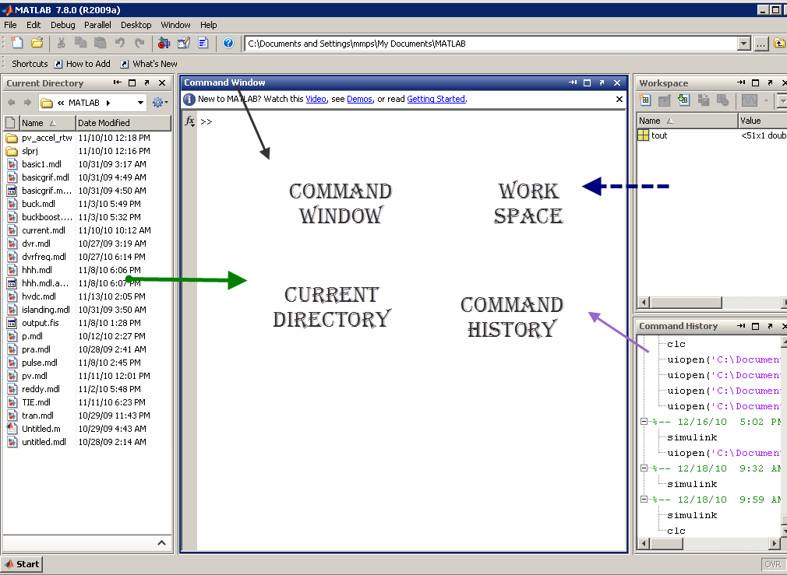

Block diagram of Mat lab components

**MATLAB and engineering:**

MATLAB was first adopted by researchers and practitioners in [control engineering](http://en.wikipedia.org/wiki/Control_engineering), Little's specialty, but quickly spread to many other domains. It is now also used in education, in particular the teaching of [linear algebra](http://en.wikipedia.org/wiki/Linear_algebra) and [numerical analysis](http://en.wikipedia.org/wiki/Numerical_analysis), and is popular amongst scientists involved in [image processing](http://en.wikipedia.org/wiki/Image_processing). However, many researchers mostly from Computer Science background feel that MATLAB should be used only for mathematical analysis necessary in image processing and not for implementation of image processing software. Moreover, MATLAB should not be used to simulate computer architectures, systems software and computer networks unless while solving some numeric problem.

**Toolboxes in Matlab:**

* Simulink
* Fuzzy
* Genetic algorithm
* Neural network
* Wavelet

**SIMULINK**

* Introduction:

Simulink is a software add-on to mat lab which is a mathematical tool developed by The Math works,(http://www.mathworks.com) a company based in Natick. Mat lab is powered by extensive numerical analysis capability. Simulink is a tool used to visually program a dynamic system (those governed by Differential equations) and look at results. Any logic circuit, or control system for a dynamic system can be built by using standard building blocks available in Simulink Libraries. Various toolboxes for different techniques, such as Fuzzy Logic, Neural Networks, DSP, Statistics etc. are available with Simulink, which enhance the processing power of the tool. The main advantage is the availability of templates / building blocks, which avoid the necessity of typing code for small mathematical processes.

* Concept of signal and logic flow:

In Simulink, data/information from various blocks are sent to another block by lines connecting the relevant blocks. Signals can be generated and fed into blocks dynamic / static).Data can be fed into functions. Data can then be dumped into sinks, which could be scopes, displays or could be saved to a file. Data can be connected from one block to another, can be branched, multiplexed etc. In simulation, data is processed and transferred only at discrete times, since all computers are discrete systems. Thus, a simulation time step (otherwise called an integration time step) is essential, and the selection of that step is determined by the fastest dynamics in the simulated system.

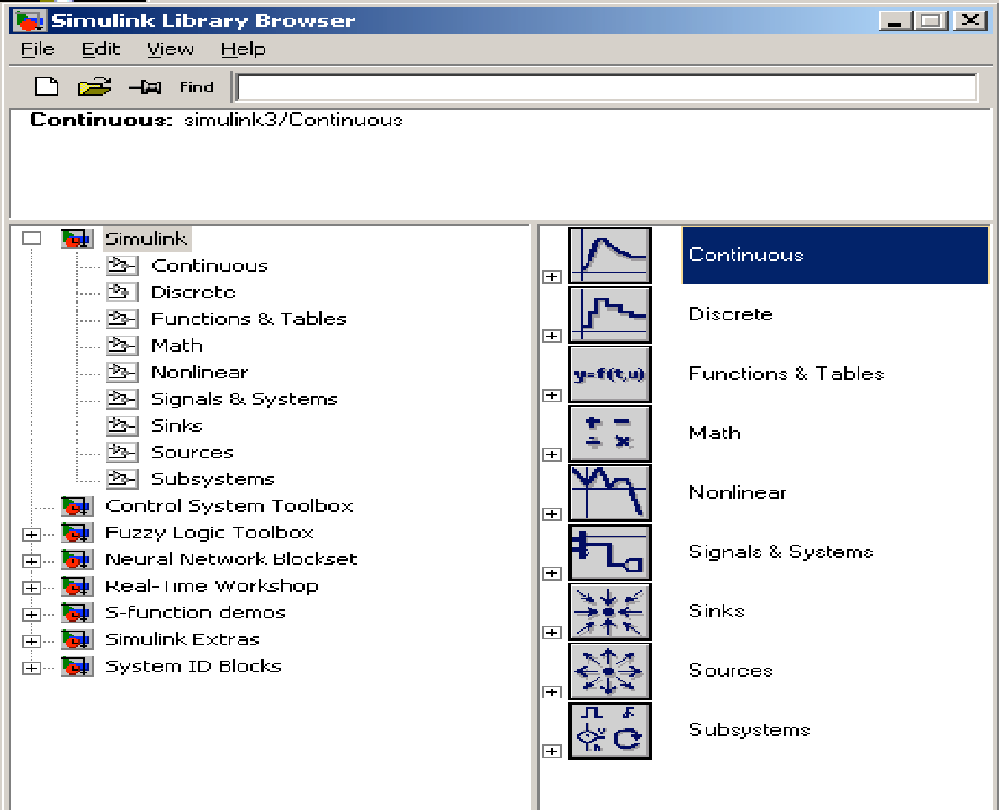

Fig 4.1 Simulink library browser

* Connecting blocks:

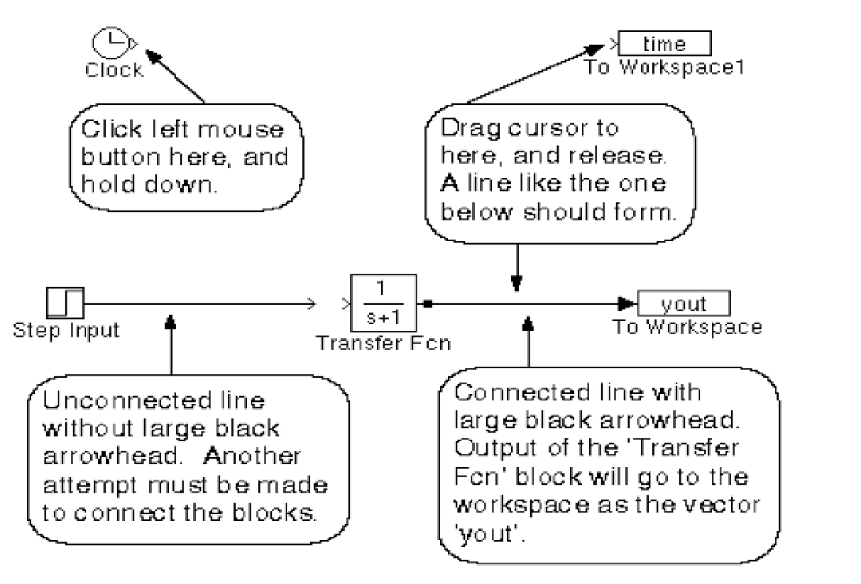

fig 4.2 Connectung blocks

To connect blocks, left-click and drag the mouse from the output of one block to the input of another block.

**Sources and sinks:**

The sources library contains the sources of data/signals that one would use in a dynamic system simulation. One may want to use a constant input, a sinusoidal wave, a step, a repeating sequence such as a pulse train, a ramp etc. One may want to test disturbance effects, and can use the random signal generator to simulate noise. The clock may be used to create a time index for plotting purposes. The ground could be used to connect to any unused port, to avoid warning messages indicating unconnected ports.

The sinks are blocks where signals are terminated or ultimately used. In most cases, we would want to store the resulting data in a file, or a matrix of variables. The data could be displayed or even stored to a file. The stop block could be used to stop the simulation if the input to that block (the signal being sunk) is non-zero. Figure 3 shows the available blocks in the sources and sinks libraries. Unused signals must be terminated, to prevent warnings about unconnected signals.

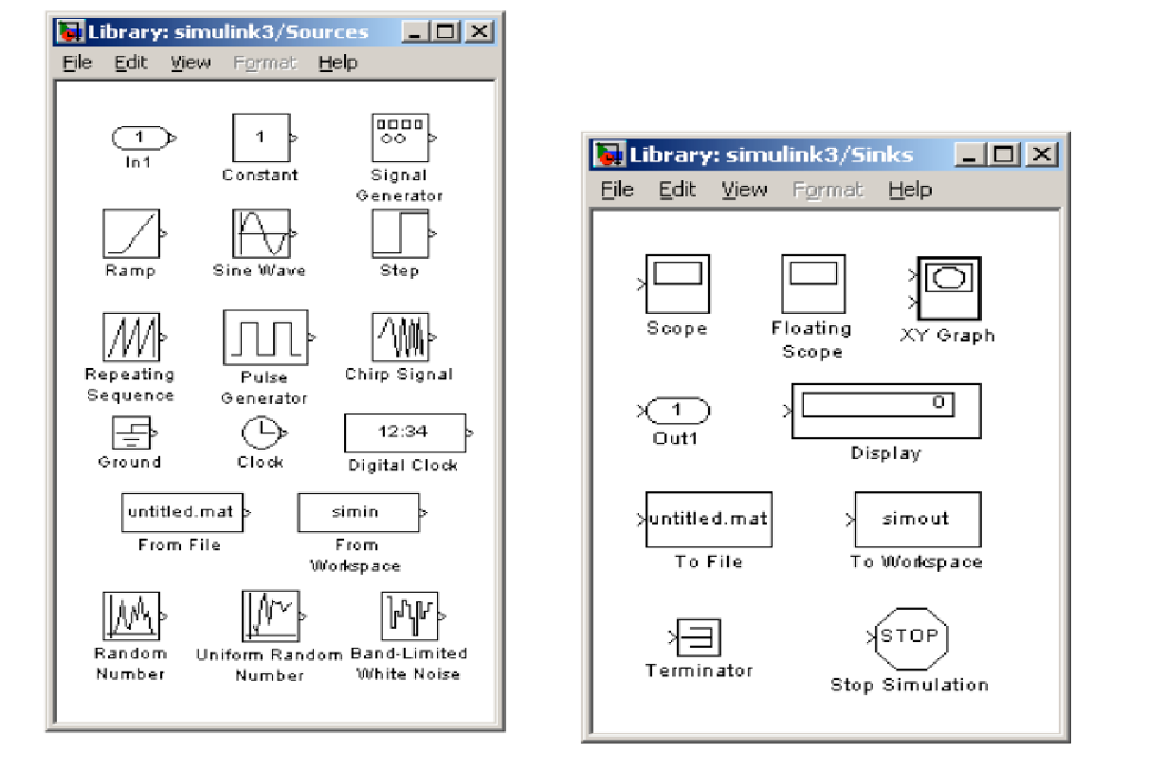

fig 4.3 Sources and sinks

* Continuous and discrete systems:

All dynamic systems can be analyzed as continuous or discrete time systems. Simulink allows you to represent these systems using transfer functions, integration blocks, delay blocks etc.

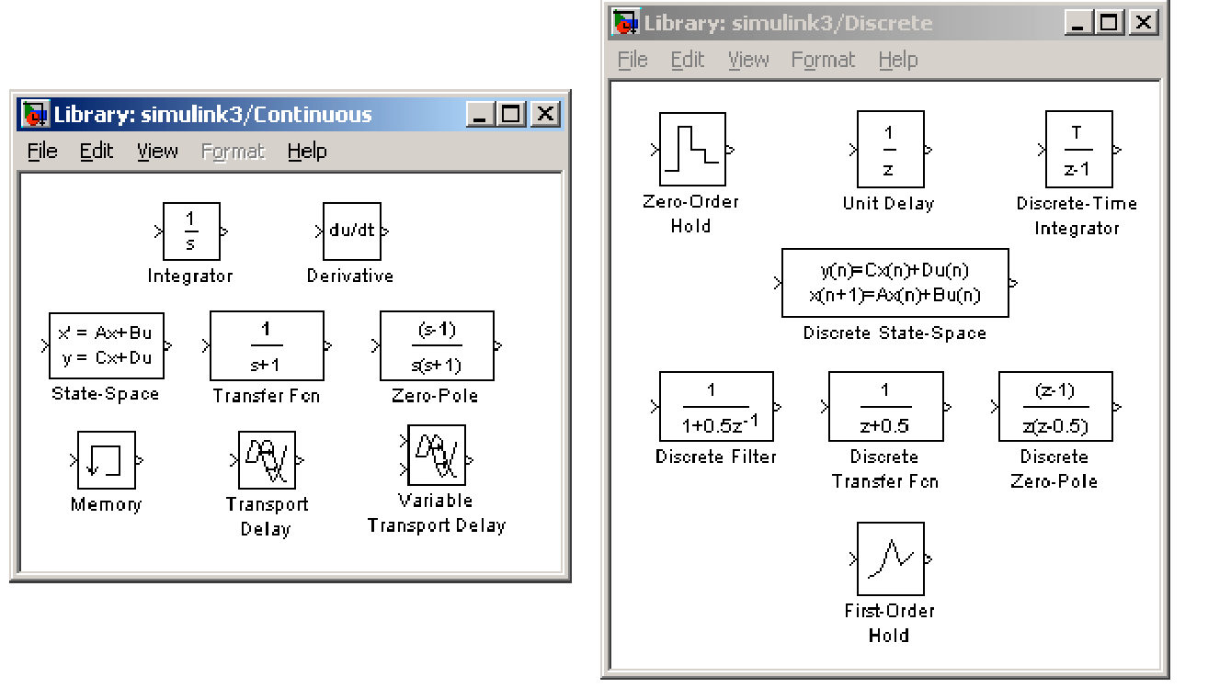

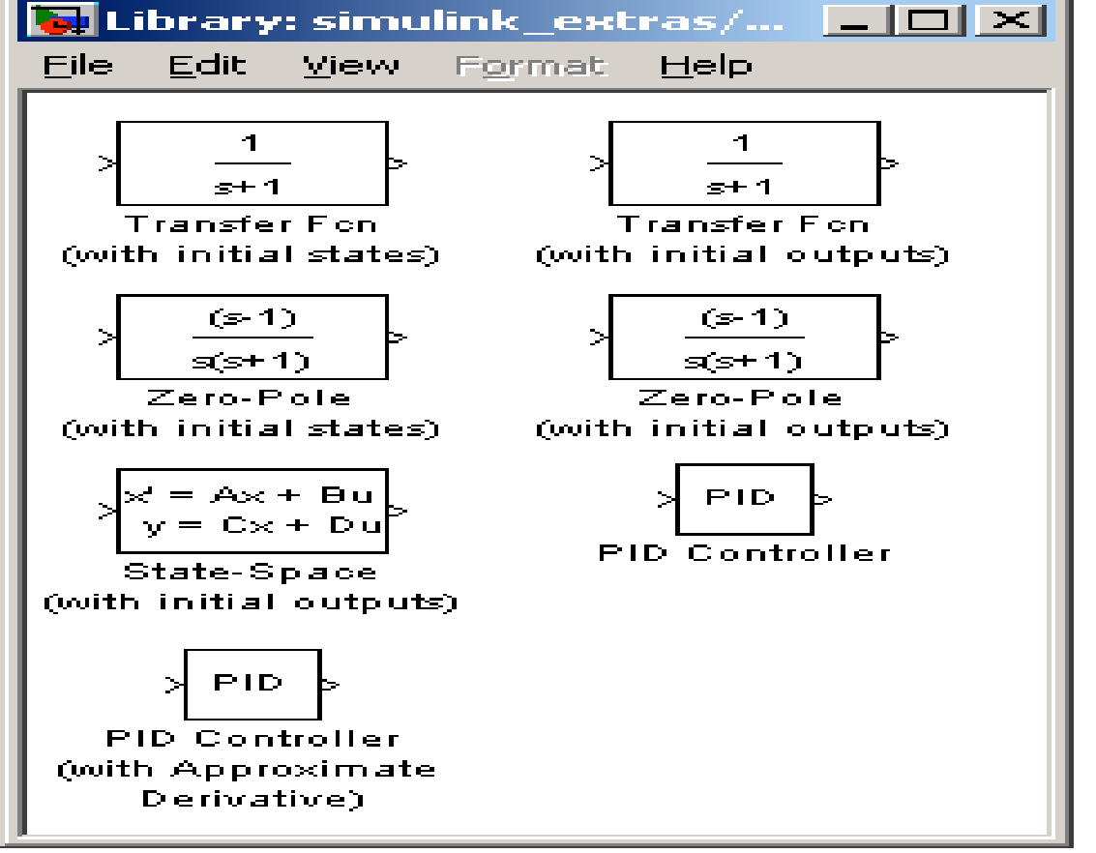

fig 4.4 continous and descrete systems

* Non-linear operators:

A main advantage of using tools such as Simulink is the ability to simulate non-linear systems and arrive at results without having to solve analytically. It is very difficult to arrive at an analytical solution for a system having non-linearities such as saturation, signup function, limited slew rates etc. In Simulation, since systems are analyzed using iterations, non-linearities are not a hindrance. One such could be a saturation block, to indicate a physical limitation on a parameter, such as a voltage signal to a motor etc. Manual switches are useful when trying simulations with different cases. Switches are the logical equivalent of if-then statements in programming.

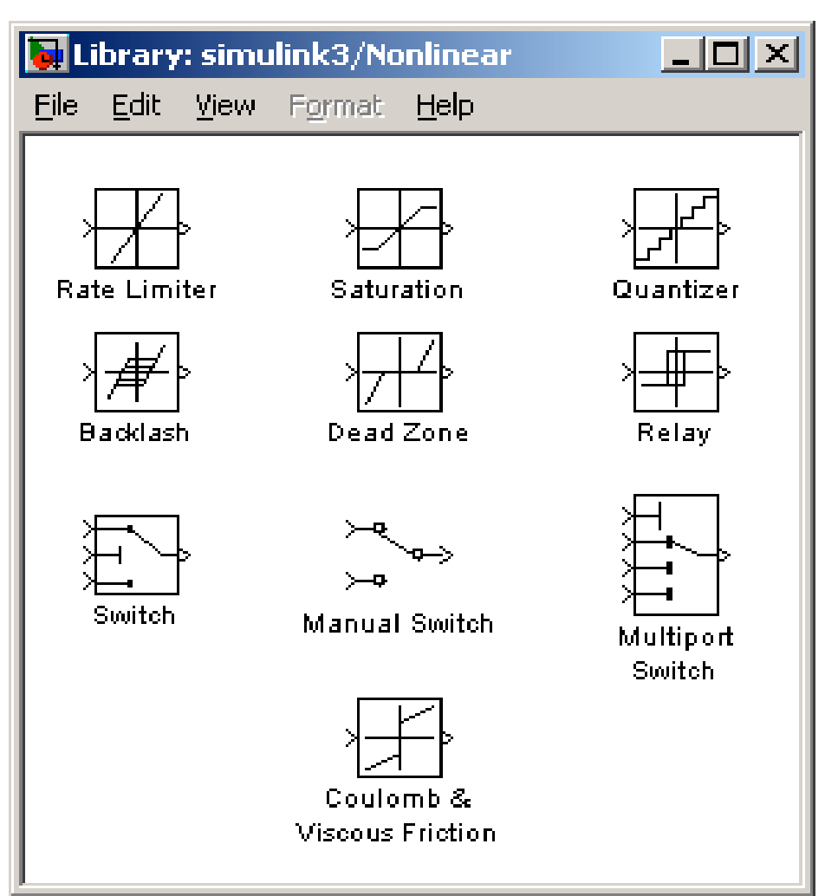

fig 4.5 simulink blocks

* Mathematical operations:

Mathematical operators such as products, sum, logical operations such as and, or, etc. can be programmed along with the signal flow. Matrix multiplication becomes easy with the matrix gain block. Trigonometric functions such as sin or tan inverse (at an) are also available. Relational operators such as ‘equal to’, ‘greater than’ etc. can also be used in logic circuits.

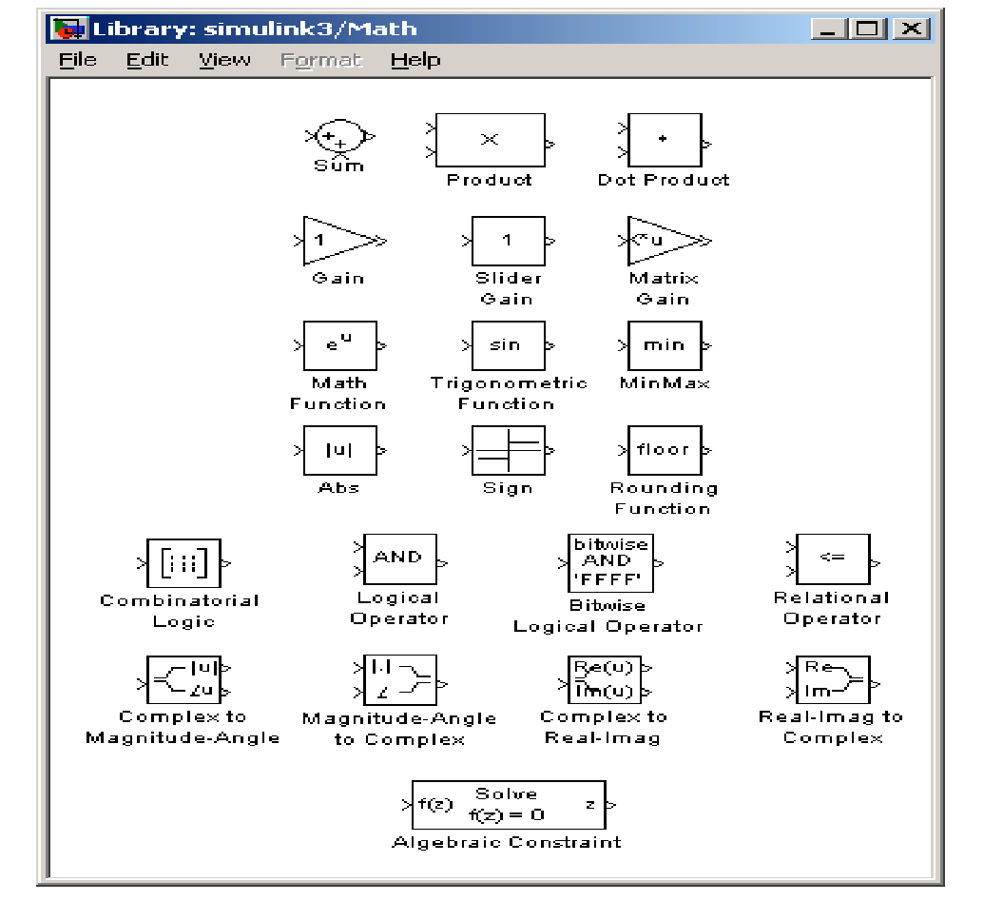

Fig 4.6 Simulink math blocks

* Signals & data transfer:

In complicated block diagrams, there may arise the need to transfer data from one portion to another portion of the block. They may be in different subsystems. That signal could be dumped into a GOTO block, which is used to send signals from one subsystem to another.

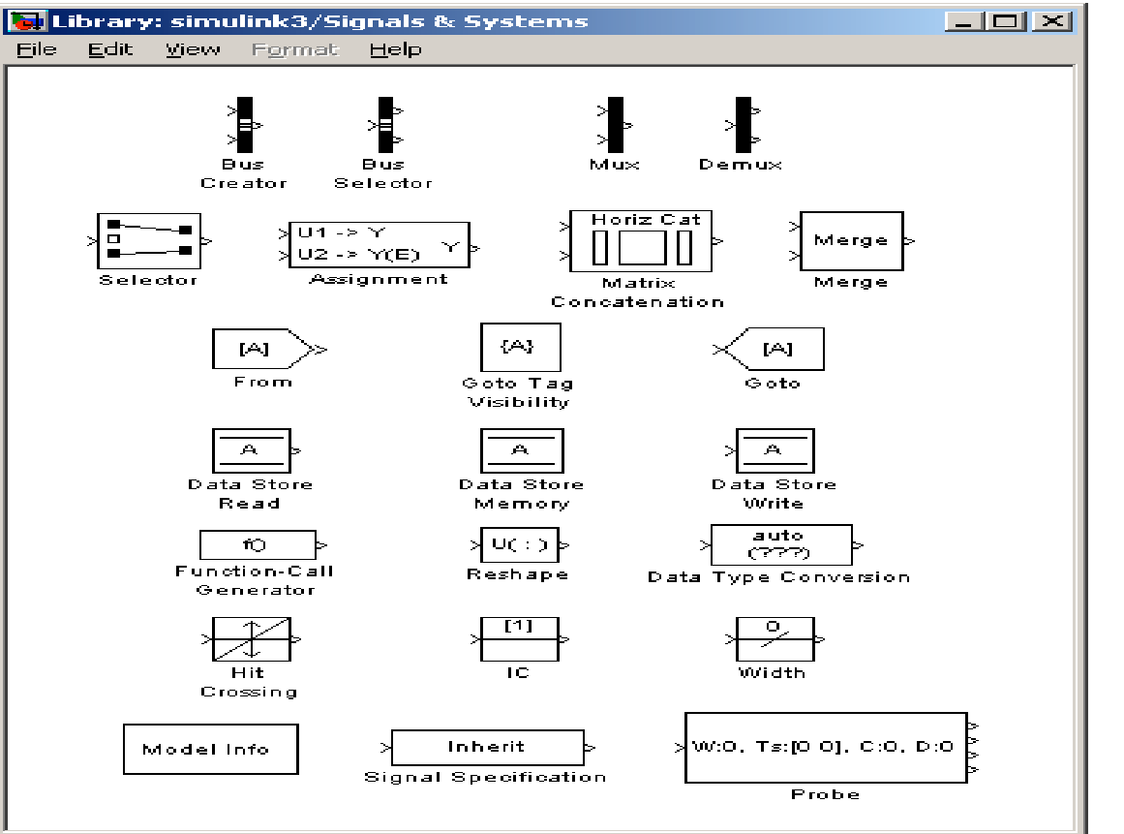

fig 4.7 signals and systems

Multiplexing helps us remove clutter due to excessive connectors, and makes matrix (column/row) visualization easier.

* Making subsystems:

Drag a subsystem from the Simulink Library Browser and place it in the parent block where you would like to hide the code. The type of subsystem depends on the purpose of the block. In general one will use the standard subsystem but other subsystems can be chosen. For instance, the subsystem can be a triggered block, which is enabled only when a trigger signal is received.

Open (double click) the subsystem and create input / output PORTS, which transfer signals into and out of the subsystem. The input and output ports are created by dragging them from the Sources and Sinks directories respectively. When ports are created in the subsystem, they automatically create ports on the external (parent) block. This allows for connecting the appropriate signals from the parent block to the subsystem.

* Setting simulation parameters:

Running a simulation in the computer always requires a numerical technique to solve a differential equation. The system can be simulated as a continuous system or a discrete system based on the blocks inside. The simulation start and stop time can be specified. In case of variable step size, the smallest and largest step size can be specified. A Fixed step size is recommended and it allows for indexing time to a precise number of points, thus controlling the size of the data vector. Simulation step size must be decided based on the dynamics of the system. A thermal process may warrant a step size of a few seconds, but a DC motor in the system may be quite fast and may require a step size of a few milliseconds.

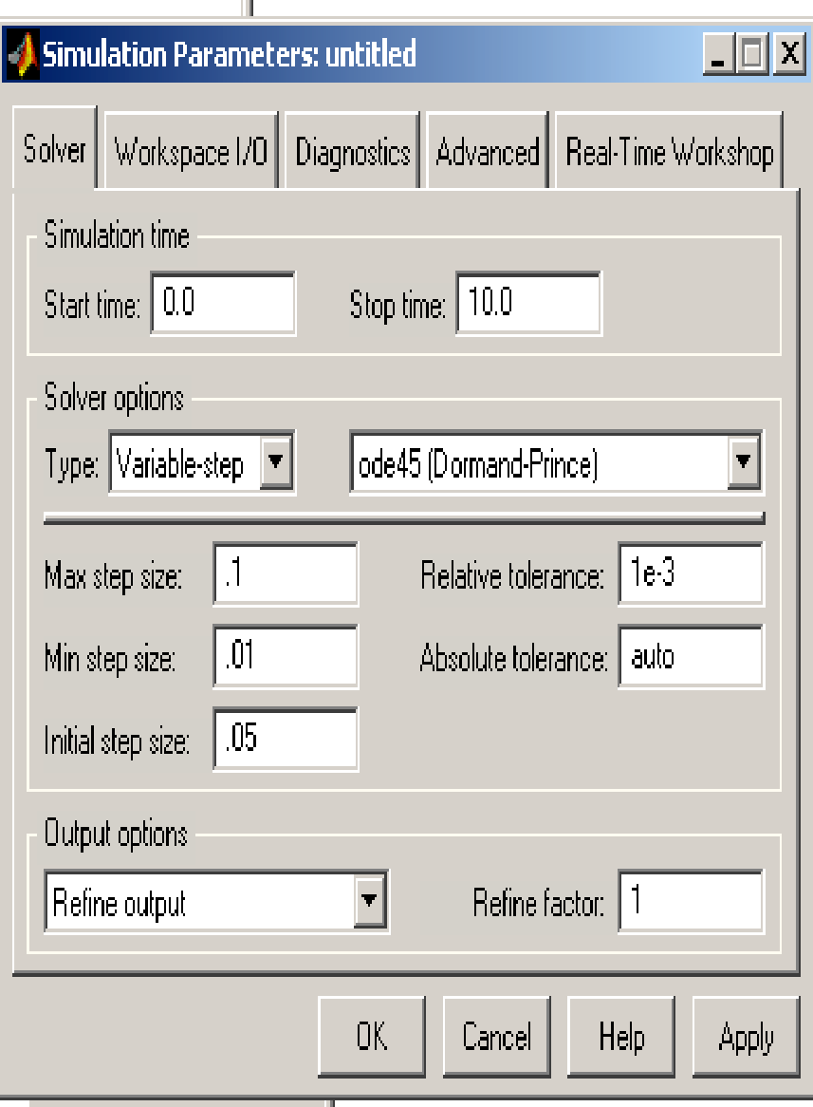 

**Simpower system:**

* Introduction:

SimPowerSystems software and other products of the Physical Modeling product family work together with Simulink software to model electrical, mechanical, and control systems.

SimPowerSystems software operates in the Simulink environment. Therefore, before starting this user's guide, make yourself familiar with [Simulink](http://www.mathworks.com/access/helpdesk/help/toolbox/simulink/) documentation. Or, if you perform signal processing and communications tasks (as opposed to control system design tasks), see the [Signal Processing Block set](http://www.mathworks.com/access/helpdesk/help/toolbox/dspblks/) documentation.

* The Role of Simulation in Design:

Electrical power systems are combinations of electrical circuits and electromechanical devices like motors and generators. Engineers working in this discipline are constantly improving the performance of the systems. Requirements for drastically increased efficiency have forced power system designers to use power electronic devices and sophisticated control system concepts that tax traditional analysis tools and techniques. Further complicating the analyst's role is the fact that the system is often so nonlinear that the only way to understand it is through simulation.

Land-based power generation from hydroelectric, steam, or other devices is not the only use of power systems. A common attribute of these systems is their use of power electronics and control systems to achieve their performance objectives.

SimPowerSystems software is a modern design tool that allows scientists and engineers to rapidly and easily build models that simulate power systems. It uses the Simulink environment, allowing you to build a model using simple *click and drag* procedures. Not only can you draw the circuit topology rapidly, but your analysis of the circuit can include its interactions with mechanical, thermal, control, and other disciplines. This is possible because all the electrical parts of the simulation interact with the extensive Simulink modeling library.

Since Simulink uses the MATLAB computational engine, designers can also use MATLAB toolboxes and Simulink block sets. SimPowerSystems software belongs to the Physical Modeling product family and uses similar block and connection line interface.

### Sim power systems Libraries:

SimPowerSystems libraries contain models of typical power equipment such as transformers, lines, machines, and power electronics. These models are proven ones coming from textbooks, and their validity is based on the experience of the Power Systems Testing and Simulation Laboratory of Hydro-Québec, a large North American utility located in Canada, and also on the experience of École de Technology Supérieure and Université Laval. The capabilities of SimPowerSystems software for modeling a typical electrical system are illustrated in demonstration files. And for users who want to refresh their knowledge of power system theory, there are also self-learning case studies.

The SimPowerSystems main library, powerlib, organizes its blocks into libraries according to their behavior. The powerlib library window displays the block library icons and names. Double-click a library icon to open the library and access the blocks. The main powerlib library window also contains the Powergui block that opens a graphical user interface for the steady-state analysis of electrical circuits.

* Nonlinear Simulink Blocks for Simpower systems Models:

The nonlinear Simulink blocks of the powerlib library are stored in a special block library named powerlib models. These masked Simulink models are used by SimPowerSystems software to build the equivalent Simulink model of your circuit. See Improving Simulation Performance for a description of the powerlib models library.

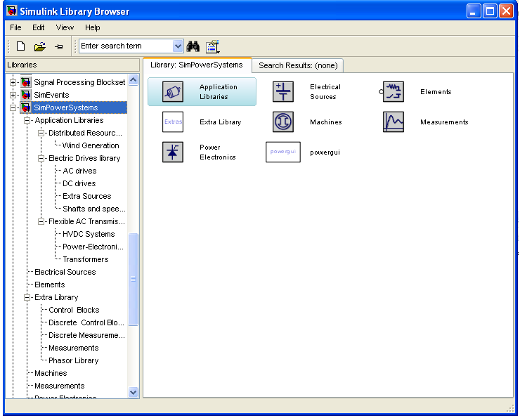

Diagram of simpower system

**Applications of Matlab:**

### MATLAB is a data-manipulation software package that allows data to be analyzed and visualized using existing functions and user-designed programs. MATLAB is a numerical computing environment and programming language. MATLAB allows easy matrix manipulation, plotting of functions and data, implementation of algorithms, creation of user interfaces, and interfacing with programs in other languages. Although it specializes in numerical computing, an optional toolbox interfaces with the Maple symbolic engine, allowing it to be part of a full computer algebra system.

### Some of the mat lab applications listed are:

### Orthogonal frequency division multiplexing

### Genetic algorithm data mining

### Speech recognition using VQ method

### Channel Estimation and Detection in DS-CDMA

### Analysis of iterative channel estimation and multi-user detection in multi path DS-CDMA channels

### Time-domain signal detection

### Time-domain signal detection based on second-order statistics for mimo-OFDM systems

### Space–time block coding

### Space–time block codes for mimo channels

### Blind channel estimation

### Basic circuit designing and analyzing of results:

Click on the file and select new model file and a file will be appeared:

Now a block and right click on it, the block will be appearing in the new model file (untitled)

For example consider a sine wave in the source block and in order to obtain or to view the output place the scope block. Join those two blocks. Now a simple circuit is ready, now set the simulation time in the tool bar (default it is set to 10.0), simulate the circuit by clicking on the simulation icon (PLAY BUTTON). Simulation is completed now by double clicking on the scope u can view the output, press the auto scale button and o/p will appear clearly

**MICROGRID**

A microgrid[1] is a decentralized group of electricity sources and loads that normally operates connected to and synchronous with the traditional wide area synchronous grid (macrogrid), but can also disconnect to "island mode" and function autonomously as physical or economic conditions dictate.[2][3] Microgrids are best served by local energy sources where power transmission and distribution from a major centralized energy source is too far and costly to execute. In this case the microgrid is also called an autonomous, stand-alone or isolated microgrid.[4][5] In this way, microgrids improve the security of supply within the microgrid cell, and can supply emergency power, changing between island and connected modes.[2] They also offer an option for rural electrification in remote areas and on smaller geographical islands. As a controllable entity, a microgrid can effectively integrate various sources of distributed generation (DG), especially renewable energy sources (RES).[4] Control and protection are difficulties to microgrids, as all ancillary services for system stabilization must be generated within the microgrid and low short-circuit levels can be challenging for selective operation of the protection systems. A very important feature is also to provide multiple end-use needs simultaneously, such as heating, cooling, and electricity, since this allows energy carrier substitution and increased energy efficiency due to waste heat utilization for heating, domestic hot water, and cooling purposes (cross sectoral energy usage)

**Definition**

The United States Department of Energy Micro grid Exchange Group[7] defines a micro grid as a group of interconnected loads and distributed energy resources (DERs) within clearly defined electrical boundaries that acts as a single controllable entity with respect to the grid. A micro grid can connect and disconnect from the grid to enable it to operate in both connected or island-mode. The EU research project[8] describes a micro grid as comprising Low-Voltage (LV) distribution systems with distributed energy resources (DERs) (micro turbines, fuel cells, photovoltaic (PV), etc.), storage devices (batteries, flywheels) energy storage system and flexible loads. Such systems can operate either connected or disconnected from the main grid. The operation of micro sources in the network can provide benefits to the overall system performance, if managed and coordinated efficiently.

**TYPES OF MICROGRIDS**

A typical scheme of an electric based micro grid with renewable energy resources in grid-connected mode Campus environment/institutional micro grids The focus of campus micro grids is aggregating existing on-site generation to support multiple loads located in a tight geographical area where an owner can easily manage them.[9][10]

**Community micro grids**

Community micro grids can serve thousands of customers and support the penetration of local energy (electricity, heating, and cooling).[11] In a community micro grid, some houses may have some renewable sources that can supply their demand as well as that of their neighbors within the same community. The community micro grid may also have a centralized or several distributed energy storages. Such micro grids can be in the form of an ac and dc micro grid coupled together through a bi-directional power electronic converter.

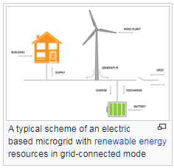

Remote off-grid microgrids These microgrids never connect to the macrogrid and instead operate in an island mode at all times because of economic issues or geographical position. Typically, an "off-grid" microgrid is built in areas that are far distant from any transmission and distribution infrastructure and, therefore, have no connection to the utility grid.[9][13] Studies have demonstrated that operating a remote area or islands' off-grid microgrids, that are dominated by renewable sources, will reduce the levelized cost of electricity production over the life of such microgrid projects.[14][15] Large remote areas may be supplied by several independent microgrids, each with a different owner (operator). Although such microgrids are traditionally designed to be energy self-sufficient, intermittent renewable sources and their unexpected and sharp variations can cause unexpected power shortfall or excessive generation in those microgrids. This will immediately cause unacceptable voltage or frequency deviation in the micro grids. To remedy such situations, it is possible to interconnect such microgrids provisionally to a suitable neighboring micro grid to exchange power and improve the voltage and frequency deviations.[16][17] This can be achieved through a power electronics-based switch[18][19] after a proper synchronization[20] or a back to back connection of two power electronic converters[21] and after confirming the stability of the new system. The determination of a need to interconnect neighboring micro grids and finding the suitable microgrid to couple with can be achieved through optimization[22] or decision making[23] approaches.

**Military base micro grids**

These micro grids are being actively deployed with focus on both physical and cyber security for military facilities in order to assure reliable power without relying on the macro grid.

**Commercial and industrial (C&I) micro grids**

These types of micro grids are maturing quickly in North America and eastern Asia; however, the lack of well–known standards for these types of micro grids limits them globally. Main reasons for the installation of an industrial micro grid are power supply security and its reliability. There are many manufacturing processes in which an interruption of the power supply may cause high revenue losses and long start-up time. Industrial micro grids can be designed to supply circular economy (near-)zero-emission industrial processes, and can integrate combined heat and power (CHP) generation, being fed by both renewable sources and waste processing; energy storage can be additionally used to optimize the operations of these sub-systems.

**Basic Components In Micro grids**

**Local generation** A microgrid presents various types of generation sources that feed electricity, heating, and cooling to the user. These sources are divided into two major groups – thermal energy sources (e.g,. natural gas or biogas generators or micro combined heat and power) and renewable generation sources (e.g. wind turbines and solar).

**Consumption**

In a microgrid, consumption simply refers to elements that consume electricity, heat, and cooling, which range from single devices to the lighting and heating systems of buildings, commercial centers, etc. In the case of controllable loads, electricity consumption can be modified according to the demands of the network.

**Energy storage**

In micro grid, energy storage is able to perform multiple functions, such as ensuring power quality, including frequency and voltage regulation, smoothing the output of renewable energy sources, providing backup power for the system and playing a crucial role in cost optimization. It includes all of chemical, electrical, pressure, gravitational, flywheel, and heat storage technologies.

When multiple energy storages with various capacities are available in a micro grid, it is preferred to coordinate their charging and discharging such that a smaller energy storage does not discharge faster than those with larger capacities. Likewise, it is preferred a smaller one does not get fully charged before those with larger capacities. This can be achieved under a coordinated control of energy storages based on their state of charge.[26] If multiple energy storage systems (possibly working on different technologies) are used and they are controlled by a unique supervising unit (an energy management system - EMS), a hierarchical control based on a master/slaves architecture can ensure best operations, particularly in the islanded mode.

**Point of common coupling (PCC)**

This is the point in the electric circuit where a micro grid is connected to a main grid.[27] Microgrids that do not have a PCC are called isolated micro grids which are usually present in remote sites (e.g., remote communities or remote industrial sites) where an interconnection with the main grid is not feasible due to either technical or economic constraints.

**Advantages and challenges of micro grids**

Advantages a micro grid is capable of operating in grid-connected and stand-alone modes and of handling the transition between the two. In the grid-connected mode, ancillary services can be provided by trading activity between the micro grid and the main grid. Other possible revenue streams exist.[28] In the islanded mode, the real and reactive power generated within the micro grid, including that provided by the energy storage system, should be in balance with the demand of local loads. Micro grids offer an option to balance the need to reduce carbon emissions with continuing to provide reliable electric energy in periods of time when renewable sources of power are not available. Micro grids also offer the security of being hardened from severe weather and natural disasters by not having large assets and miles of above-ground wires and other electric infrastructure that need to be maintained or repaired following such events.A micro grid may transition between these two modes because of scheduled maintenance, degraded power quality or a shortage in the host grid, faults in the local grid, or for economical reasons.[30][31] By means of modifying energy flow through microgrid components, microgrids facilitate the integration of renewable energy, such as photovoltaic, wind and fuel cell generations, without requiring re-design of the national distribution system.[31][32][33] Modern optimization methods can also be incorporated into the microgrid energy management system to improve efficiency, economics, and resiliency.[29][34][33][35] Challenges Microgrids, and the integration of DER units in general, introduce a number of operational challenges that need to be addressed in the design of control and protection systems, in order to ensure that the present levels of reliability are not significantly affected, and the potential benefits of Distributed Generation (DG) units are fully harnessed.

Some of these challenges arise from assumptions typically applied to conventional distribution systems that are no longer valid, while others are the result of stability issues formerly observed only at a transmission system level.[30] The most relevant challenges in microgrid protection and control include: Bidirectional power flows: The presence of distributed generation (DG) units in the network at low voltage levels can cause reverse power flows that may lead to complications in protection coordination, undesirable power flow patterns, fault current distribution, and voltage control.[30] Stability issues: Interactions between control system of DG units may create local oscillations, requiring a thorough small-disturbance stability analysis. Moreover, transition activities between the grid-connected and islanding (stand-alone) modes of operation in a microgrid can create transient instability.

Recent studies have shown that direct-current (DC) microgrid interface can result in a significantly simpler control structure, more energy efficient distribution and higher current carrying capacity for the same line ratings.[37][38] Modeling: Many characteristics of traditional schemes such as the prevalence of three-phase balanced conditions, primarily inductive transmission lines, and constant-power loads, do not necessarily hold true for microgrids, and consequently, models need to be revised.[30] Low inertia: Microgrids exhibit a low-inertia characteristic that makes them different to bulk power systems, where a large number of synchronous generators ensures a relatively large inertia. This phenomenon is more evident if there is a significant proportion of power electronic-interfaced DG units in the microgrid. The low inertia in the system can lead to severe frequency deviations in island mode operation if a proper control mechanism is not implemented.[30] Synchronous generators run at the same frequency as the grid, thus providing a natural damping effect on sudden frequency variations. Synchronverters are inverters which mimic synchronous generators to provide frequency control. Other options include controlling battery energy storage or a flywheel to balance the frequency.[39] Uncertainty: The operation of microgrids involves addressing much uncertainty, which is something the economical and reliable operation of microgrids relies on. Load profile and weather are two uncertainties that make this coordination more challenging in isolated microgrids, where the critical demand-supply balance and typically higher component failure rates require solving a strongly coupled problem over an extended time horizon. This uncertainty is higher than those in bulk power systems, due to the reduced number of loads and highly correlated variations of available energy resources (the averaging effect is much more limited).[30] Modelling tools To plan and install micro grids correctly, engineering modelling is needed. Multiple simulation tools and optimization tools exist to model the economic and electric effects of microgrids.

A widely used economic optimization tool is the Distributed Energy Resources Customer Adoption Model (DER-CAM) from Lawrence Berkeley National Laboratory. Another is Homer Energy, originally designed by the National Renewable Energy Laboratory. There are also some power flow and electrical design tools guiding micro grid developers. The Pacific Northwest National Laboratory designed the publicly available GridLAB-D tool and the Electric Power Research Institute (EPRI) designed OpenDSS. A European tool that can be used for electrical, cooling, heating, and process heat demand simulation is EnergyPLAN from Aalborg University in Denmark. The open source grid planning tool OnSSET has been deployed to investigate microgrids using a three‑tier analysis beginning with settlement archetypes (case‑studied using Bolivia)

**Microgrid control Hierarchical Control**

In regards to the architecture of microgrid control, or any control problem, there are two different approaches that can be identified: centralized[29][41] and decentralized.[42] A fully centralized control relies on a large amount of information transmittence between involving units before a decision is made at a single point. Implementation is difficult since interconnected power systems usually cover extended geographic locations and involve an enormous number of units. On the other hand, in a fully decentralized control, each unit is controlled by its local controller without knowing the situation of others.[43] A compromise between those two extreme control schemes can be achieved by means of a hierarchical control scheme consisting of three control levels: primary, secondary, and tertiary

**Primary control**

The primary control is designed to satisfy the following requirements: To stabilize the voltage and frequency To offer plug and play capability for DERs and properly share the active and reactive power among them, preferably, without any communication links To mitigate circulating currents that can cause over-current phenomenon in the power electronic devices The primary control provides the setpoints for a lower controller which are the voltage and current control loops of DERs. These inner control loops are commonly referred to as zero-level control.[45]

**Secondary control**

Secondary control has typically seconds to minutes sampling time (i.e. slower than the previous one) which justifies the decoupled dynamics of the primary and the secondary control loops and facilitates their individual designs. The set point of primary control is given by secondary control[46] in which, as a centralized controller, it restores the micro grid voltage and frequency and compensates for the deviations caused by variations of loads or renewable sources. The secondary control can also be designed to satisfy the power quality requirements, e.g., voltage balancing at critical buses.

**Tertiary control**

Tertiary control is the last (and the slowest) control level, which considers economical concerns in the optimal operation of the micro grid (sampling time is from minutes to hours), and manages the power flow between micro grid and main grid.[45] This level often involves the prediction of weather, grid tariff, and loads in the next hours or day to design a generator dispatch plan that achieves economic savings.[33] More advanced techniques can also provide end to end control of a micro grid using machine learning techniques such as deep reinforcement learning.[47] In case of emergencies such as blackouts, tertiary control can manage a group of interconnected micro grids to form what is called "micro grid clustering", acting as a virtual power plant to continue supplying critical loads. During these situations the central controller should select one of the micro +grids to be the slack (i.e. master) and the rest as PV and load buses according to a predefined algorithm and the existing conditions of the system (i.e. demand and generation). In this case, the control should be real time or at least at a high sampling rate.

**DC Fast Charging**

DC Fast Charging bypasses all of the limitations of the on-board charger and required conversion, instead providing DC power directly to the battery, charging speed has the potential to be greatly increased. Charging times are dependent on the battery size and the output of the dispenser, and other factors, but many vehicles are capable of getting an 80% charge in about or under an hour using most currently available DC fast chargers. DC fast charging is essential for high mileage/long distance driving and large fleets. The quick turnaround enables drivers to recharge during their day or on a small break as opposed to being plugged in overnight, or for many hours, for a full charge. Older vehicles had limitations that only allowed them to charge at 50kW on DC units (if they were able to at all) but newer vehicles are now coming out that can accept up to 270kW. Because battery size has increased significantly since the first EVs hit the market, DC chargers have been getting progressively higher outputs to match – with some now being capable of up to 350kW.

Currently, in North America there are three types of DC fast charging: CHAdeMO, Combined Charging System (CCS) and Tesla Supercharger. All major DC charger manufacturers offer multi-standard units that offer the ability to charge via CCS or CHAdeMO from the same unit. The Tesla Supercharger can only service Tesla vehicles, however Tesla vehicles are capable of using other chargers, specifically CHAdeMO for DC fast charging, via an adapter.

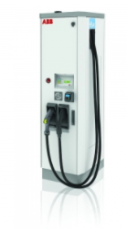

**COMBINED CHARGING SYSTEM (CCS)**

The Combined Charging System (CCS) is based on open and universal standards for electric vehicles. The CCS combines single-phase AC, three-phase AC and DC high-speed charging in both Europe and the US – all in a single, easy to use system. The CCS includes the connector and inlet combination as well as all the control functions. It also manages communications between the electric vehicle and the infrastructure. As a result, it provides a solution to all charging requirements.



**CHAdeMO**

CHAdeMO is a DC charging standard for electric vehicles. It enables seamless communication between the car and the charger. It is developed by CHAdeMO Association, which is also tasked with certification, ensuring compatibility between the car and the charger. The Association is open to every organization that works for the realization of electro mobility. The Association, established in Japan, now has hundreds of members from around the globe. In Europe, CHAdeMO members based in the branch office in Paris, France, actively reach out to and work with the European members.

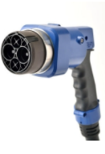

**Tesla Supercharger**

Tesla has installed their own proprietary chargers throughout the country (and the world) to provide long distance driving capability to Tesla vehicles. They are also placing chargers in urban areas that are available for drivers through their daily lives. Tesla is currently has over 1,600 Supercharger stations across North America

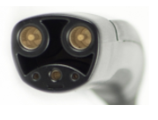

**GRID-TIE INVERTER**

A grid-tie inverter converts direct current (DC) into an alternating current (AC) suitable for injecting into an electrical power grid, normally 120 V RMS at 60 Hz or 240 V RMS at 50 Hz. Grid-tie inverters are used between local electrical power generators: solar panel, wind turbine, hydro-electric, and the grid.[1] To inject electrical power efficiently and safely into the grid, grid-tie inverters must accurately match the voltage and phase of the grid sine wave AC waveform. Some electricity companies pay for electrical power that is injected into the grid.

**Payment for injected power**

Electricity companies, in some countries, pay for electrical power that is injected into the electricity utility grid. Payment is arranged in several ways. With net metering the electricity company pays for the net power injected into the grid, as recorded by a meter in the customer's premises. For example, a customer may consume 400 kilowatt-hours over a month and may return 500 kilowatt-hours to the grid in the same month. In this case the electricity company would pay for the 100 kilowatt hours balance of power fed back into the grid. In the US, net metering policies vary by jurisdiction.

Feed-in tariff, based on a contract with a distribution company or other power authority, is where the customer is paid for electrical power injected into the grid. In the United States, grid-interactive power systems are specified in the National Electric Code, which also mandates requirements for grid-interactive inverters.

**Operation**

Grid-tie inverters convert DC electrical power into AC power suitable for injecting into the electric utility company grid. The grid tie inverter (GTI) must match the phase of the grid and maintain the output voltage slightly higher than the grid voltage at any instant. A high-quality modern grid-tie inverter has a fixed unity power factor, which means its output voltage and current are perfectly lined up, and its phase angle is within 1 degree of the AC power grid.

The inverter has an on-board computer that senses the current AC grid waveform, and outputs a voltage to correspond with the grid. However, supplying reactive power to the grid might be necessary to keep the voltage in the local grid inside allowed limitations. Otherwise, in a grid segment with considerable power from renewable sources, voltage levels might rise too much at times of high production, i.e. around noon with solar panels. Grid-tie inverters are also designed to quickly disconnect from the grid if the utility grid goes down.

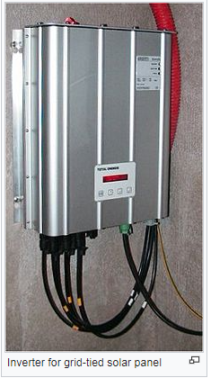

This is an NEC requirement[2] that ensures that in the event of a blackout, the grid tie inverter shuts down to prevent the energy it transfers from harming any line workers who are sent to fix the power grid. Properly configured, a grid tie inverter enables a home owner to use an alternative power generation system like solar or wind power without extensive rewiring and without batteries. If the alternative power being produced is insufficient, the deficit is sourced from the electricity grid.

**Types**

Inside an SWEA 250 W transformer-coupled grid-tie inverter Grid-tie inverters include conventional low-frequency types with transformer coupling, newer high-frequency types, also with transformer coupling, and transformerless types.[3] Instead of converting direct current directly into AC suitable for the grid, high-frequency transformers types use a computer process to convert the power to a high-frequency and then back to DC and then to the final AC output voltage suitable for the grid.[4] Transformerless inverters, which are popular in Europe, are lighter, smaller, and more efficient than inverters with transformers. But transformerless inverters have been slow to enter the US market because of concerns that transformerless inverters, which do not have galvanic isolation between the DC side and grid, could inject dangerous DC voltages and currents into the grid under fault conditions.[5] However, since 2005, the NFPA's NEC allows transformerless, or non-galvanically isolated, inverters by removing the requirement that all solar electric systems be negative grounded and specifying new safety requirements. Amendments to VDE 0126-1-1 and IEC 6210 define the design and procedures needed for such systems: primarily, ground current measurement and DC to grid isolation tests.

**Datasheets**

Manufacturers datasheets for their inverters usually include the following data:

**Rated output power:** This value is provided in watts or kilowatts. For some inverters, they may provide an output rating for different output voltages. For instance, if the inverter can be configured for either 240 VAC or 208 VAC output, the rated power output may be different for each of those configurations.

**Output voltage(s):** This value indicates the utility voltages the inverter can connect to. For smaller inverters for residential use, the output voltage is usually 240 VAC. Inverters that target commercial applications are available for 208, 240, 277, 400, 480 or 600 VAC and may also produce three phase power.

**Peak efficiency:** The peak efficiency represents the highest efficiency that the inverter can achieve. Most grid-tie inverters on the market as of July 2009 have peak efficiencies of over 94%, some as high as 96%. The energy lost during inversion is for the most part converted into heat. Consequently, for an inverter to output its rated power it must have a power input that exceeds its output. For example, a 5000 W inverter operating at full power at 95% efficiency requires an input of 5,263 W (rated power divided by efficiency). Inverters that are capable of producing power at different AC voltages may have different efficiencies associated with each voltage.

**CEC weighted efficiency:** This efficiency is published by the California Energy Commission on its GoSolar website. In contrast to peak efficiency, this value is an average efficiency and is a better representation of the inverter's operating profile. Inverters that are capable of producing power at different AC voltages may have different efficiencies associated with each voltage.

**Maximum input current:** This is the maximum amount of direct current that the inverter can use. If a system, solar cells for example, produces a current in excess of the maximum input current, that current is not used by the inverter. Maximum output current: The maximum output current is the maximum continuous alternating current that the inverter can supply. This value is typically used to determine the minimum current rating of the over-current protection devices (e.g., breakers and fuses) and disconnects required for the output circuit. Inverters that can produce power at different AC voltages have different maximum outputs for each voltage.

**Peak power tracking voltage:** This represents the DC voltage range in which the inverter's maximum point power tracker operates. The system designer must configure the strings optimally so that during the majority of the year, the voltage of the strings are within this range. This can be a difficult task since voltage fluctuates with temperature changes.

**Start voltage:** This value is not listed on all inverter datasheets. The value indicates the minimum DC voltage required for the inverter to turn on and operate. This is especially important for solar applications, because the system designer must be sure that there is a sufficient number of solar modules wired in series in each string to produce this voltage. If this value is not provided by the manufacturer, system designers typically use the lower band of the peak power tracking voltage range as the inverter's minimum voltage.

**IPxx rating:** The Ingress Protection rating or IP Code classifies and rates the level of protection provided against the ingress of solid foreign objects (first digit) or water (second digit), a higher digit means greater protection. In the US the NEMA enclosure type is used similarly to the international rating. Most inverters are rated for outdoors installation with IP45 (no dust protection) or IP65 (dust tight), or in the US, NEMA 3R (no windblown dust protection) or NEMA 4X (windblown dust, direct water splash and additional corrosion protection). Certifications/Compliance: Certifications required by electric utilities and local electric codes for grid tie approval such as UL 1741[7] and emerging standard UL 1741SA.

**INTRODUCTION**

Energy storage systems are important components of a micro-grid as they enable the integration of intermittent renewable energy sources. Electric vehicle (EV) batteries can be utilized as effective storage devices in micro-grids when they are plugged-in for charging. Most personal transportation vehicles sit parked for about 22 hours each day, during which time they represent an idle asset. EVs could potentially help in micro-grid energy management by storing energy when there is surplus (Grid-To-Vehicle, G2V) and feeding this energy back to the grid when there is demand for it (Vehicle-To-Grid). V2G applied to the general power grid faces some challenges such as; it is complicated to control, needs large amount of EVs and is hard to realize in short term [1].

In this scenario, it is easy to implement V2G system in a micro-grid. The Society of Automotive Engineers defines three levels of charging for EVs. Level 1 charging uses a plug to connect to the vehicle’s on-board charger and a standard household (120 V) outlet. This is the slowest form of charging and works for those who travel less than 60 kilometers a day and have all night to charge. Level 2 charging uses a dedicated Electric Vehicle Supply Equipment (EVSE) at home or at a public station to provide power at 220 V or 240 V and up to 30 A. The level 3 charging is also referred to as dc fast charging. DC fast charging stations provide charging power up to 90 kW at 200/450 V, reducing the charging time to 20-30 mins. DC fast charging is preferred for implementing a V2G architecture in micro-grid due to the quick power transfer that is required when EVs are utilized for energy storage. Also the dc bus can be used for integrating renewable generation sources into the system. In majority of the previous studies, V2G concept has been applied in the general power grid for services like peak shaving, valley filling, regulation and spinning reserves [2].

The V2G development in a micro-grid facility to support power generation from intermittent renewable sources of energy is still at its infancy. Also, level 1 and level 2 ac charging is utilized for V2G technology in most of the works reported [3]. These ac charging systems are limited by the power rating of the on-board charger. An additional issue is that the distribution grid has not been designed for bi-directional energy flow. In this scenario, there is a research need for developing technically viable charging station architectures to facilitate V2G technology in micro-grids.

This work proposes a dc quick charging station infrastructure with V2G capability in a micro-grid facility. The dc bus used to interface EVs is also used for integrating a solar photo-voltaic (PV) array into the micro-grid. The proposed architecture allows high power bi-directional charging for EVs through off-board chargers. Effectiveness of the proposed model is evaluated based on MATLAB/Simulink simulations for both V2G and G2V modes of operation.

**II. DC FAST CHARGING STATION CONFIGURATION FOR V2G**

The configuration for dc fast charging station to implement V2G-G2V infrastructure in a micro-grid is shown in Fig. 1 [4]. EV batteries are connected to the dc bus through off-board chargers. A grid connected inverter connects the dc bus to the utility grid through an LCL filter and a step-up transformer. The important components of the charging station are described below.

1. **Battery Charger Configuration**

For dc fast charging, the chargers are located off-board and are enclosed in an EVSE. A bidirectional dc-dc converter forms the basic building block of an off-board charger with V2G capability. It forms the interface between EV battery system and the dc distribution grid. The converter configuration is shown in Fig. 2. It consists of two IGBT/MOSFET switches that are always operated by complimentary control signals. 1) Buck mode of operation ( charging mode): When the upper switch (Sbuck) is operating, the converter acts as a buck converter stepping down the input voltage (Vdc) to battery charging voltage (Vbatt)During the on state, current flows through the switch and inductor to the battery. This is the charging operation, where the power flow is from the grid to vehicle (G2V).

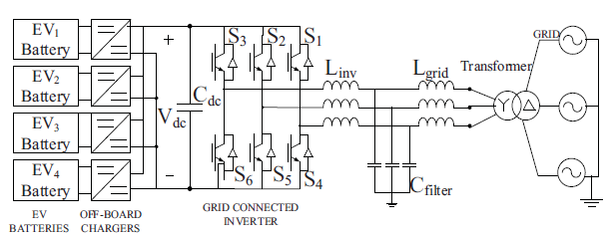

Fig. 1. EV charging station for fast dc charging

When the switch is off, the current takes its return path through the inductor and diode of lower switch and completes the circuit. If is the duty ratio of the upper switch, the battery voltage is given by:

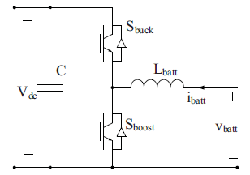

Fig.2. Battery charger configuration



2) Boost mode of operation (discharging mode): when the lower switch (S) is operating, the converter acts as a boost converter stepping up the battery voltage (Vbatt) to the DC B bus voltage (Vdc).When the switch is in on state, current continues to flow through the inductor and completes its circuit through the anti-parallel diode of the upper switch, and the capacitor. The net power flow in this case is from the vehicle to the grid (V2G) and the battery operates in the discharge mode. If the capacitor is large enough to provide a constant dc voltage, the output voltage during boost mode of operation is given by



()where D’ is the duty cycle of the lower switch.

1. **Grid Connected Inverter and LCL Filter**

The grid connected inverter (GCI) converts the dc bus voltage into a three phase ac voltage and also allows the reverse flow of current through the anti-parallel diodes of the switches in each leg (Fig. 1). An LCL filter is connected at the output terminals of the inverter for harmonic reduction and obtaining a pure sinusoidal voltage and current. The design procedure for determining the LCL filter parameters for this work is adapted from [4].

**III. CONTROL SYSTEM**

1. **Off-Board Charger Control**

A constant current control strategy [5] using PI controllers is implemented for charge/discharge control of the battery charger circuit and is shown in Fig.3. The controller first compares the reference battery current with zero, in-order to determine the polarity of the current signal, to decide between charging and discharging modes of operations. Once the mode is selected, the reference current is compared with the measured current and the error is passed through a PI controller to generate the switching pulses for  will be turned off throughout the charging process and  will be turned off throughout the discharging process

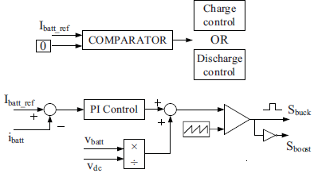

Fig. 3. Constant current control strategy for battery charger

1. **Inverter Control**

A cascade control in synchronous reference frame is proposed for the inverter controller. The conventional standard vector control using 4 PI controllers in a nested loop is shown in Fig. 4 [4]. The control structure consists of two outer voltage control loops and two inner current control loops. The d-axis outer loop controls the dc bus voltage and inner loop controls the active ac current. Similarly, the q-axis outer loop regulates the ac voltage magnitude by adjusting the reactive current, which is controlled by the q-axis inner current loop. Also, dq decoupling terms L and feed-forward voltage signals are added to improve the performance during transients.

**IV. MICRO-GRID TEST SYSTEM CONFIGURATION**

The micro-grid test system configuration with the dc fast charging station is shown in Fig. 5. A 100 kW wind turbine (WT) and a 50 kW solar PV array serve as the generation sources

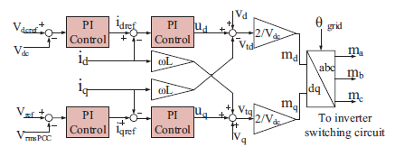

Fig. 4. Inverter control system in the system.

The EV battery storage system consists of 4 EV batteries connected to a 1.5 kV dc bus of the charging station through off-board chargers. The solar PV is also connected to this dc bus through a boost converter which has a maximum power point tracking (MPPT) controller. The utility grid consists of a 25 kV distribution feeder and a 120 kV equivalent transmission system. The wind turbine driven doubly-fed induction generator is connected to the micro-grid at the point of common coupling (PCC). Transformers are used to step up the voltages and connect the respective ac systems to the utility grid.

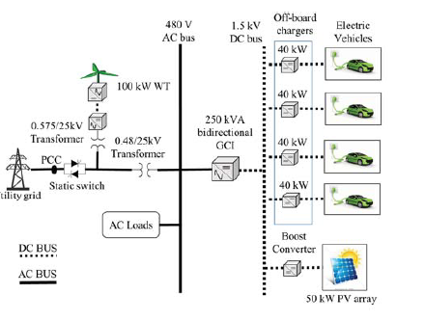

Fig. 5. Proposed microgrid test system configuration

**V. SIMULATION RESULTS**

The charging station design procedure is adapted from [4] and the obtained parameter values are given in Appendix. The wind turbine is operated at rated speed giving an output maximum power of 100 kW. The solar PV is operated at standard test conditions (1000W/m2 irradiance and 25oC temperature) giving the maximum power output of 50 kW. A 150 kW resistive load is connected to the 480 V ac bus. The reactive current reference to GCI is set to zero for unity pf operation. The initial state of charge (SOC) of the EV batteries is set at 50%. Once the steady state conditions are reached, batteries of EV1 and EV2 (Fig. 1) are operated to perform the V2G-G2V power transfer. The current set-points given to the battery charging circuits of EV1 and EV2 batteries are shown in Table I and the results are shown in the subsequent figures. The battery parameters when EV1 is operating in V2G mode and EV2 operating in G2V mode are shown in Figs. 6 and 7, respectively.

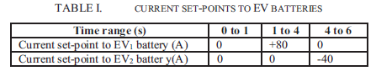

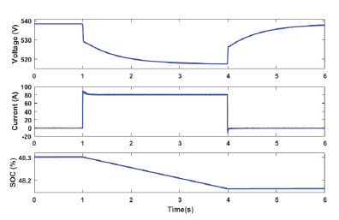

Fig. 6. Voltage, current, and SOC of EV1 battery during V2G operation

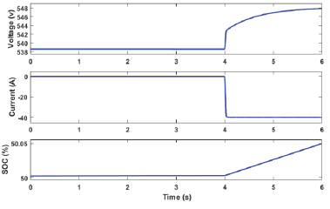

Fig. 7. Voltage, current, and SOC of EV2 battery during G2V operation

The active power contribution from various components of the system is shown in Fig. 8. The grid power changes to accommodate the power transferred by the EVs. The negative polarity of the grid power from 1s to 4s shows that the power is being fed to the grid from the vehicle. The change in polarity of grid power at 4s shows that the power is supplied by the grid for charging the vehicle battery. This demonstrates the V2G-G2V operation. Also, the net power at PCC is zero showing an optimal power balance in the system.

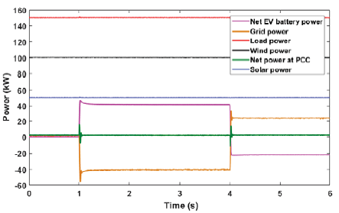

Fig. 8. Active power profile of various components in the system

The dc bus voltage is regulated at 1500 V by the outer voltage control loop of the inverter controller and is shown in Fig. 9. This in turn is achieved by the inner current control loop tracking the changed d-axis reference current as shown in Fig. 10.

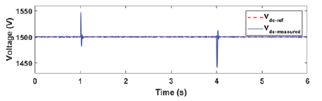

Fig. 9. Variation in dc bus voltage

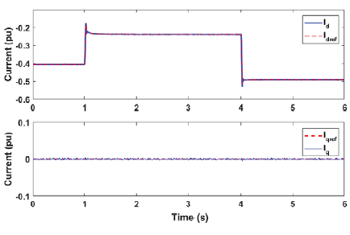

Fig. 10. Reference current tracking by inverter controller

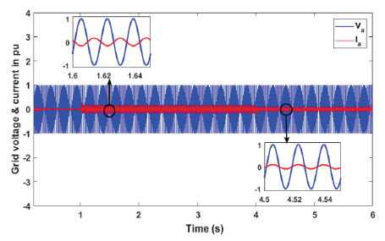

Fig. 11. Grid voltage and grid injected current during V2G-G2V operation

Total harmonic distortion (THD) analysis is done on the grid injected current and the result is shown in Fig. 12. According to IEEE Std. 1547, harmonic current distortion on power systems 69 kV and below are limited to 5% THD. The THD of gridinjected current is obtained as 2.31 % and is achieved by the judicious design of LCL filter.

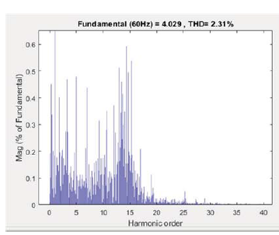

Fig. 12. Harmonic spectrum and THD of grid-injected current

**VI. CONCLUSIONS**

Modeling and design of a V2G system in a micro-grid using dc fast charging architecture is presented in this paper. A dc fast charging station with off-board chargers and a grid connected inverter is designed to interface EVs to the microgrid. The control system designed for this power electronic interface allows bi-directional power transfer between EVs and the grid. The simulation results show a smooth power transfer between the EVs and the grid, and the quality of grid injected current from the EVs adheres to the relevant standards. The designed controller gives good dynamic performance in terms of dc bus voltage stability and in tracking the changed active power reference. Active power regulation aspects of the microgrid are considered in this work, and the proposed V2G system can be utilized for several other services like reactive power control and frequency regulation. Design of a supervisory controller which gives command signals to the individual EV charger controllers is suggested for future research.

R**EFERENCES**

[1] C. Shumei, L. Xiaofei, T. Dewen, Z. Qianfan, and S. Liwei, “The construction and simulation of V2G system in micro-grid,” in Proceedings of the International Conference on Electrical Machines and Systems, ICEMS 2011, 2011, pp. 1–4.

[2] S. Han, S. Han, and K. Sezaki, “Development of an optimal vehicle-togrid aggregator for frequency regulation,” IEEE Trans. Smart Grid, vol. 1, no. 1, pp. 65–72, 2010.

[3] M. C. Kisacikoglu, M. Kesler, and L. M. Tolbert, “Single-phase on-board bidirectional PEV charger for V2G reactive power operation,” IEEE Trans. Smart Grid, vol. 6, no. 2, pp. 767–775, 2015.

[4] A. Arancibia and K. Strunz, “Modeling of an electric vehicle charging station for fast DC charging,” in Proceedings of the IEEE International Electric Vehicle Conference (IEVC), 2012, pp. 1–6.

[5] K. M. Tan, V. K. Ramachandaramurthy, and J. Y. Yong, “Bidirectional battery charger for electric vehicle,” in 2014 IEEE Innovative Smart Grid Technologies - Asia, ISGT ASIA 2014, 2014, pp. 406–411.